Bets-164.5

First

100 euro on – 104.5 euros .. won 4.5 euros.



Second

50 euro on , lost.. Paderborn won 6-0

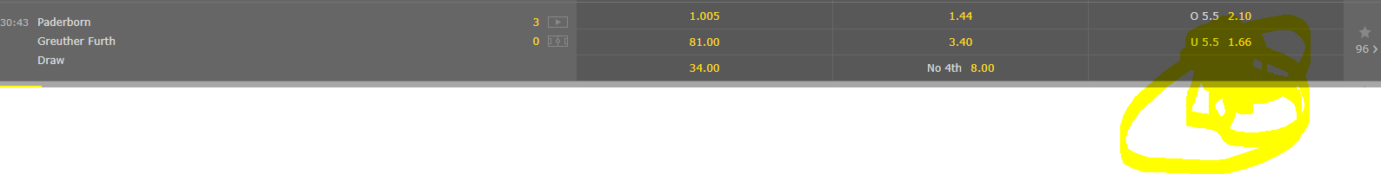

Third

10 euro on draw lost 10 euro.

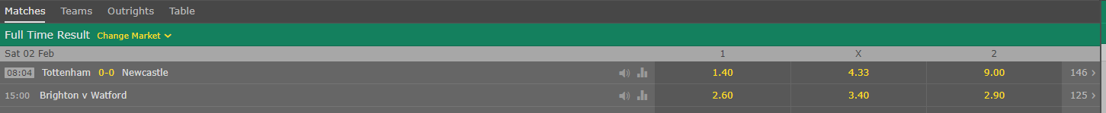

Fourth

40 euros on Corners less than 11 = 20 euros win